**Week 1 Outline and Sources**

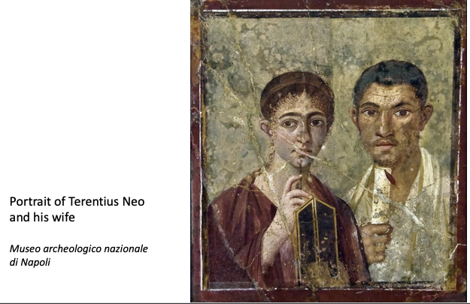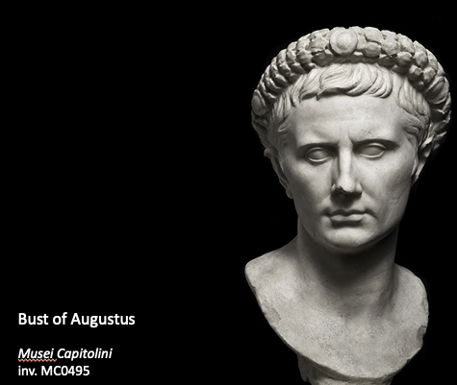**Coverage of the textbook**

1. The civic crown given by the senate was a symbol of both the military and political success.
2. Wax tablets and a pen; scroll; toga

**Course aims**

1. Overview of historical developments and chief events, and how they are interrelated.
2. Periodization

753 – 509 BC: Kingdom

509 – 28/27 BC: Republic

28/27 BC – AD 284: Principate

284 AD – AD 476: Late Roman Empire

1. All the 3 transitions are gradual processes, less revolutionary than people think, and occurred due to long-term crises. The periodization is based purely on the constitution.
2. Myth of Lucretia
3. *res publica*

Public affairs, commonwealth, “state”

1. Explanation of the sources that underlie our knowledge of the past.
2. Literary texts
3. Wide variety of genres ranging from historiography, biography, oratory, poetry, geography, legal works, technical treatises (e.g., on grammar, land surveying, military science), and novels.

* Historiography (历史编纂学)
* Herodotus (c. 484-425 BC), *Histories.* Known as the "Father of History," Herodotus was a Greek historian who wrote Histories, a comprehensive account of the Greco-Persian Wars as well as the customs, geography, and conflicts of various peoples known to the Greeks. His work is divided into nine books, each named after one of the Muses. Herodotus traveled extensively across the Mediterranean and Near East, gathering stories and firsthand accounts, which he wove into a narrative that sought to explain the causes and events of the wars between Greece and Persia. His methodology (方法论) combined historical fact with folklore (民间传说) and anecdote, providing rich information that offers insights into the cultures and events of his time.
* Fabius Pictor (c. 200 BC), *Annales*.
* Polybius (c. 200-118 BC), *The Histories*. A Greek historian who was brought to Rome as a hostage, Polybius wrote a comprehensive history of Rome’s rise to power, focusing on the period from 264 to 146 BC, including the Punic Wars.
* Cato the Elder (234-149 BC), *Origines*.
* Sallust (86-35 BC), *The Conspiracy of Catiline, The Jugurthine War*.
* Livy (59 BC-AD 17), *Ab Urbe Condita Libri* (Books from the Foundation of the City). Livy’s monumental history of Rome covered its foundation up to his own time, though only a fraction of the original 142 books survive. His work is known for its literary style and moralizing (说教的) tone.
* Dionysius of Halicarnassus (c. 60 BC - after AD 7), *Roman Antiquities.*
* Tacitus (c. AD 56 - c. 120), *Annals, Histories, Germania, Agricola.* Tacitus is known for his detailed and critical approach to the history of the Roman Empire, focusing on the reigns of the emperors from Tiberius to Domitian.
* Suetonius (c. AD 69 - c. 122), *The Twelve Caesars*.
* Cassius Dio (c. AD 155 - c. 235), *Roman History.* Dio’s extensive history covers Rome from its mythical beginnings to AD 229. His work is particularly valuable for its detailed accounts of the late Republic and early Empire.
* Biography
* Gaius Suetonius Tranquillus (c. AD 69-122), *De Vita Caesarum* (The Twelve Caesars). Suetonius’ most famous work comprises biographies of the first twelve Roman emperors, from Julius Caesar to Domitian. His biographies are rich in anecdotes, personal details, and scandalous stories, offering a vivid portrayal of each emperor's character and reign.
* Plutarch (c. AD 46-120), *Parallel Lives*. Although Plutarch was Greek, his work had a profound influence on Roman literature. *Parallel Lives* pairs the biographies of notable Greeks and Romans, drawing moral comparisons between their lives. His detailed and anecdotal style provides deep insights into the personalities and moral character of his subjects. Although Plutarch was Greek, his work had a profound influence on Roman literature. Parallel Lives pairs the biographies of notable Greeks and Romans, drawing moral comparisons between their lives. His detailed and anecdotal style provides deep insights into the personalities and moral character of his subjects.
* Oratory
* Speeches recorded after the speech.
* M. Tullius Cicero.
* Poetry
* Quintus Ennius (239-169 BC), *Annales (a historical epic), various tragedies*. Ennius is best known for his epic poem *Annales*, which chronicled Roman history from its legendary beginnings to his own time. He is considered the father of Roman epic poetry and had a profound influence on later poets like Virgil.
* Virgil (70-19 BC), *Aeneid, Eclogues (or Bucolics), Georgics*. Virgil is one of Rome’s greatest poets. His *Aeneid* is an epic poem that tells the story of Aeneas, a Trojan who travels to Italy and becomes the ancestor of the Romans. His *Eclogues* and *Georgics* are pastoral poems that explore themes of rural life and agriculture.
* Horace (65-8 BC), *Odes, Satires, Epodes, Epistles.* Horace’s poetry covers a wide range of themes, including love, friendship, philosophy, and satire. His *Odes* are particularly celebrated for their lyrical beauty and philosophical depth.
* Geography
* Strabo (64/63 BC – AD 24), *Geographica* (Geography). A Greek historian and geographer, Strabo wrote Geographica, a comprehensive work that covers the geography of the known world, including Europe, Asia, and Africa. Strabo’s work is a vital source for understanding the geographical knowledge and theories of the ancient world.
* Legal works
* Many important works.

1. 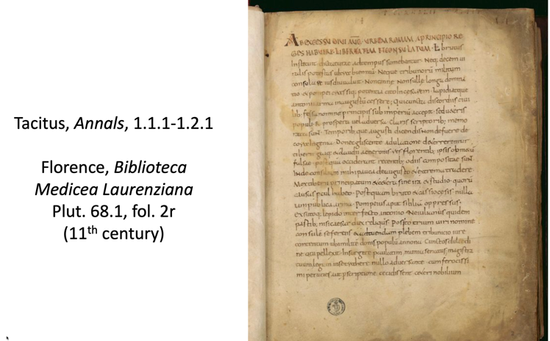Most of the literary texts that have been (partially) preserved have been handed down to us through a manuscript tradition (most medieval). Very few texts have been handed down to us via ancient copies written on papyrus.
2. Inscriptions

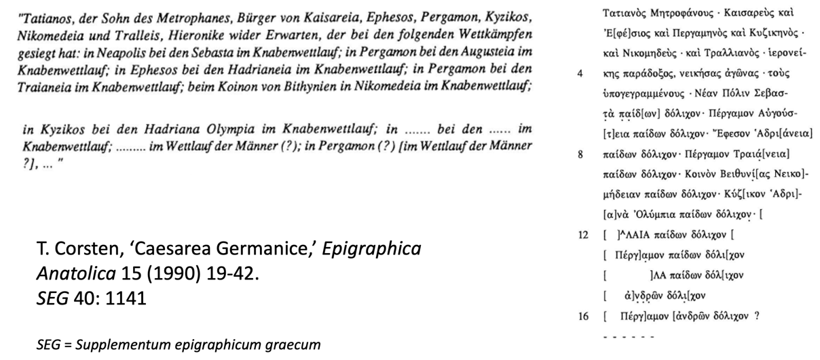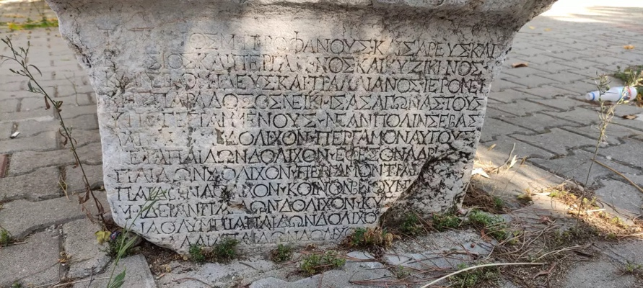Texts engraved in or written on durable material, usually stone or metal.

*SEG*: 古希腊罗马铭文集

In Greek; Sports achievement

1. Papyri

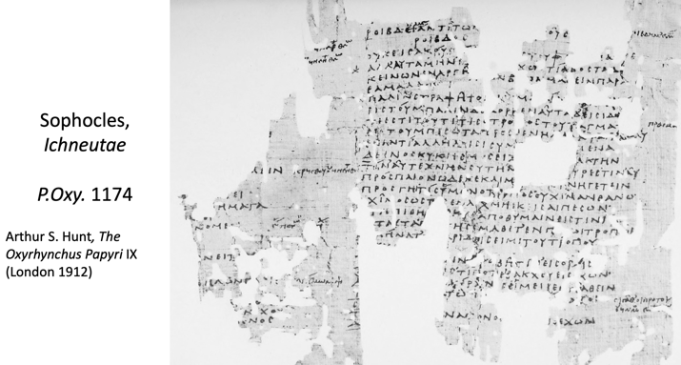Texts written on papyrus (see below). The nature of the texts contained in papyrus could be very diverse: e.g., various types of documents, literary texts, magical texts, contracts, and leases, etc.

1. Material remains

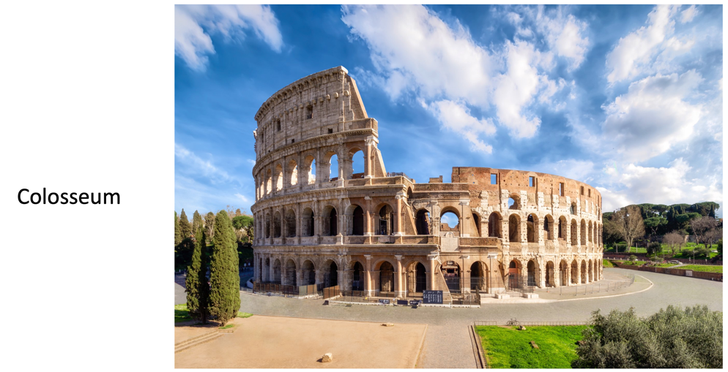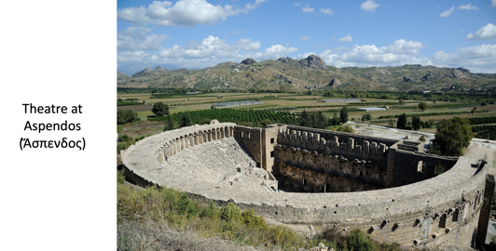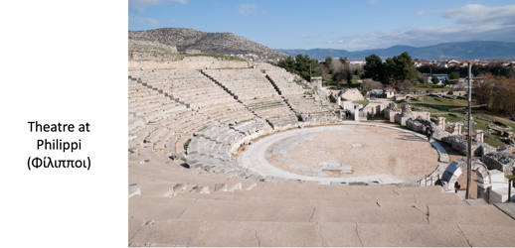Any material that remained from the time of ancient Rome, ranging from works of art and monumental buildings to the remains of ordinary dwellings, foundations, structures of a utilitarian (实用的) purpose, and utensils (用具).

1. The Theatre at Philippi, located in the ancient city of Philippi in eastern Macedonia (modern Greece), is a significant archaeological site that showcases the architectural and cultural achievements of the ancient Greeks and Romans.

* Founding: The city of Philippi was founded in 356 BC by King Philip II of Macedon, the father of Alexander the Great. It became an important city in the region due to its strategic location on the Via Egnatia, a major Roman road connecting the Adriatic Sea to Byzantium (modern Istanbul).
* Roman Influence: Philippi gained prominence after the Battle of Philippi in 42 BC, where the forces of Mark Antony and Octavian (the future Emperor Augustus) defeated the army of the assassins of Julius Caesar. The city was later developed into a Roman colony, and many Roman architectural styles and structures were introduced.

1. The Theatre at Aspendos, located in the ancient city of Aspendos in present-day Turkey, is one of the best-preserved examples of Roman theater architecture.

* Founding: Aspendos, known in antiquity as Ἄσπενδος (Aspendos), was an ancient Greco-Roman city located in Pamphylia, near the modern city of Antalya. It was founded by Greeks from Argos around 1000 BC.
* Roman Period: The city flourished during the Roman period, becoming an important cultural and economic center. The theatre was constructed during this time, under the reign of Emperor Marcus Aurelius (AD 161-180).

1. 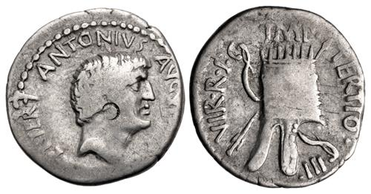Coinage

M. Antony (37/36 BC) AR Denarius (3.56 g). Head of Antony right; ANTONIVS · AVGV[R · COS · DES · ITER · ET · ] TERT around / Armenian tiara, bow and arrow behind; IMP · TERTIO · III · VIR · R · P · C arounds. Courtesy of Classical Numismatic Group, Inc., www.cngcoins.com. Electronic Auction 486, Lot: 499.

1. Construction of historical argumentations based on the ancient source material.
2. Organization of the field of Roman history: where and how can you find the ancient sources? Where can you find the research literature (scholarship)?